

D Y Patil International University
School of Computer Science Engineering and Applications

LAB MANUAL
BASIC ELECTRICAL AND ELECTRONICS ENGINEERING
First Year B.Tech. – Computer Science Engineering
Academic Year: 2026–27

Certificate

This is to certify that ________________________________, PRN. ______________, of First Year B.Tech., Sem I, Div___________ has satisfactorily completed the practical work prescribed for the course Basic Electrical and Electronics Engineering Laboratory during the academic year 2026–27.

 | Dr.Kiran Bhandari | Dr.Rahul Sharma
Faculty In-charge | HOD | Director

University Vision
"To Create a vibrant learning environment – fostering innovation and creativity, experiential learning, which is inspired by research, and focuses on regionally, nationally and globally relevant areas."

University Mission
· To provide a diverse, vibrant and inspirational learning environment.
· To establish the university as a leading experiential learning and research oriented center.
· To Become a responsive university serving the needs of industry and society.
· To embed internationalization, employability and value thinking.

School Vision
“To be a center of excellence in computer science education and research, fostering innovation, ethical values, and technological solutions that address regional, national, and global challenges through experiential learning and cutting-edge research.”

School Mission
· To cultivate a dynamic and inclusive learning environment that encourages creativity, critical thinking, and hands-on engagement in cutting-edge technologies.
· To integrate research-driven teaching practices with emerging industry trends, promoting innovation and entrepreneurship.
·To prepare students for global careers through interdisciplinary education and employability-focused programs.
· To nurture socially responsible technologists committed to sustainable development and ethical computing practices.

Course Outcomes (COs)
CO1 | Explain the fundamental concepts of electrical quantities, circuit elements, and sources, and apply Ohm’s Law, KCL, and KVL to analyze and solve basic electrical circuits.
CO2 | Explain the basic characteristics and working principles of semiconductor devices and apply PN junction and Zener diodes in switching, rectification, and voltage regulation circuits.
CO3 | Explain sensors and Arduino and apply basic sensor interfacing techniques for real-world applications.
CO4 | Analyze BJT and MOSFET characteristics and apply them as electronic switches and amplifiers
CO5 | Explain the basic characteristics of operational amplifiers and apply Op-Amp configurations for signal amplification and basic mathematical operations.

Laboratory Safety Guidelines:
- Switch OFF the power supply before making or modifying circuit connections.
- Verify component ratings and polarity before energizing a circuit.
- Use a properly rated multimeter and select the correct measurement range.
- Do not short-circuit a power supply or connect components directly across an unsuitable source.
- Keep the workbench dry and organized.
- Disconnect the Arduino USB/power supply before changing wiring.
- Report damaged components, loose wires or faulty equipment to the laboratory instructor.
- Record observations with appropriate units and significant figures.

INDEX
Sr. No. | Experiment Title | Performance Date | Submission Date | Sign
1 | Identification and Measurement of Basic Electronic Components
2 | Verification of Kirchhoff’s Laws (KVL & KCL) – Apply KVL in a series circuit and KCL in a parallel circuit, and verify through measurements.
3 | A. Study V-I characteristics of P-N Junction Diode  B. Zener Diode as a Voltage Regulator
4 | Study of Half-Wave Rectifier – Observe input and output waveforms, and calculate ripple factor.
5 | Study of Full-Wave Rectifiers (Center-tap & Bridge) – Compare performance of full-wave rectifiers with half-wave rectifier.
6 | Introduction to Arduino UNO – Familiarization with Arduino UNO, Arduino IDE, digital/analog pins and basic programming; interface an LED and push button.
7 | LDR-Based Light Sensing using Arduino – Interface an LDR with Arduino and control an LED based on light intensity.
8 | Basic Op-Amp Applications – Implement and verify inverting, non-inverting amplifier and voltage follower circuits.
9 | BJT as a Switch – Demonstrate switching action of a transistor using LED or small load.
10 | Mini project

Experiment 1
Identification and Measurement of Basic Electronic Components

Aim: To identify common electronic components and measure their electrical values using a digital
multimeter.

Simulation Tools and Components:Tinkercad, Resistors, Capacitors, Inductors, Diode, LED, Transistor, Breadboard, Digital Multimeter, jumper wires.

About Tinkercad :
Tinkercad is a free, easy-to-use web app by Autodesk for 3D design, electronics, and coding. It runs directly in your web browser without requiring any downloads, making it a popular starting point for students, teachers, hobbyists, and beginners learning STEM skill.
Circuits: Allows users to build, wire, and test virtual electronic assemblies, including microcontrollers like Arduino, without needing physical hardware.

Theory:
Resistor: It is a passive electrical component with the primary function to limit the flow of electric current. The resistance is measured in ohms (Ω). An ohm is the resistance that occurs when a current of one ampere (A) passes through a resistor with a one volt (V) drop across its terminals. The current is proportional to the voltage across the terminal ends. This ratio is represented by Ohm’s law:
R=V Ω
I
Resistor values are often indicated with color codes. The color code is given by several bands. Together they specify the resistance value, the tolerance, and sometimes the reliability or failure rate. The number of bands varies from three to six. The first two bands indicate the resistance value and the third band serves as a multiplier. The chart below shows how to determine the resistance and tolerance for resistors.

How to Read Resistor Color Code?
- To read them, hold the resistor such that the tolerance band is on your right. The tolerance band is usually gold or silver in color and is placed a little further away from the other bands.
- Starting from your left, note down all the colors of the bands and write them down in sequence.
- Next, use the table given below to see which digits they represent.
- The band just next to the tolerance band is the multiplier band. So if the color of this band is Red (representing 2), the value given is 10².
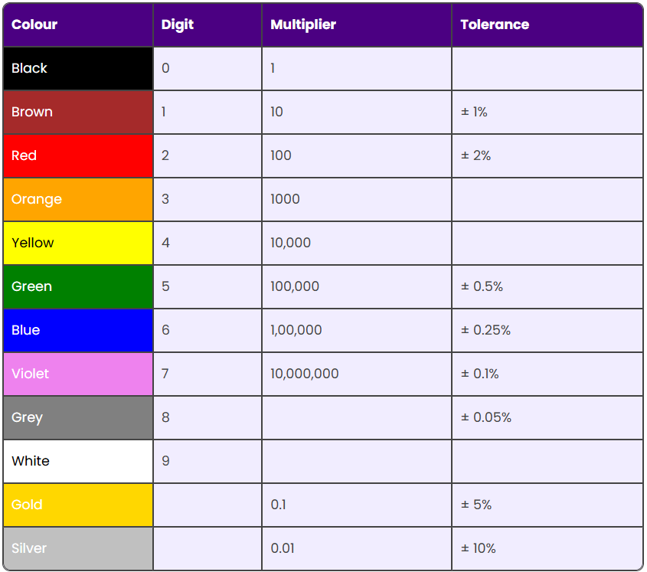

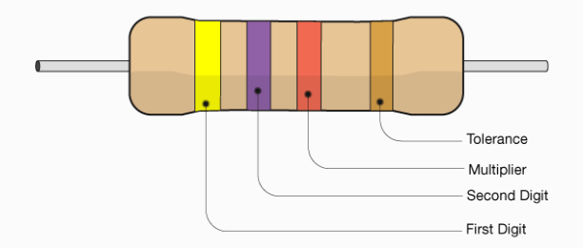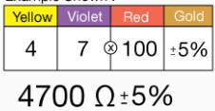

Procedure to find out Resistance
1. Visually identify each component and note its marking or color code.
2. Set the multimeter to the appropriate mode and range for measuring resistance.
3. Measure resistor values and compare them with their values calculated using color-code .

Observation Table –For Resistor
Sr.No. | Color band | Calculated value

Capacitors: A capacitor is a passive electronic component that stores electrical energy in an electric field between two conductive plates separated by an insulating material (dielectric). When voltage is applied, it accumulates charge and releases it when needed. Capacitors are widely used in electronic circuits for energy storage, filtering, signal processing, and voltage regulation.
There are various kinds of capacitor available in different shapes and sizes depends on its dielectric material and voltage rating. It can be selected according to the application of the circuit. To know in detail, we will start with the structure of a physical capacitor.
Types of capacitors
      - Ceramic Capacitors (Disc and MLCC)
Formed from a ceramic disc coated with silver electrodes, these through-hole components excel in high-voltage applications.

Reading the 3-Digit Code
- First digit: First main number.
- Second digit: Second main number.
- Third digit: Multiplier (number of zeros to add).
- Base unit: Always picofarads (pF)
Eg: 104= 10 X 10^4 = 100,000 pF
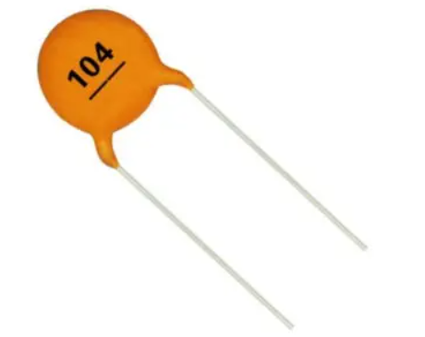

Procedure to find out Capacitor value
1. Visually identify each component and note rating.
2. Set the multimeter to the appropriate mode and range for capacitor.
3. Measure capacitor values where the meter supports capacitance measurement.
4. Measure capacitor values and compare them with their printed values.
Sr.No. | Capacitor | Calculated value
      - Electrolytic Capacitors
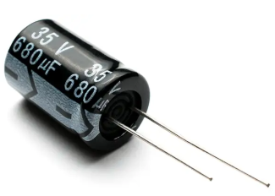
These capacitors offer high capacitance values within a compact package, making them ideal for applications such as power supply filtering and energy storage. Electrolytic capacitors are polarized, so they must be installed in the correct direction in a circuit.

3. Tantalum Capacitors
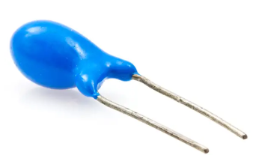
Tantalum capacitors excel in space-constrained or high-performance applications, such as smartphones and medical devices, due to their compactness, stability, and reliability. They are also polarized and known for their precise performance and long lifespan.

4. Film Capacitors
These capacitors have a plastic film as the dielectric, hence the name. Film capacitors offer excellent reliability, low distortion, and high voltage handling, making them well-suited for audio systems, motor drives, and precision timing circuits.
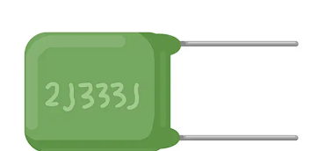

5. Super Capacitors
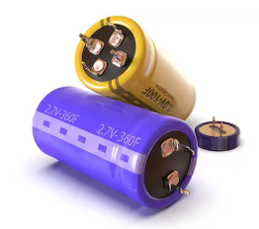
Also known as ultra-capacitors, super capacitors store significantly more energy than traditional capacitors and charge and discharge very quickly. Super capacitors are best suited for applications that require fast, repeated charging cycles, such as energy harvesting and backup power systems.

Inductors:
An inductor is a passive two-terminal electronic component that stores electrical energy in the form of a magnetic field when electric current flows through it.It is usually a coil of wire. Its main job is to fight sudden changes in the flow of current.

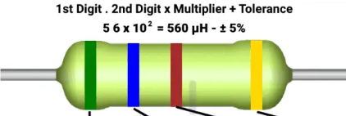

Diode
Diode is a two terminal device. The two terminals are anode and cathode. It allows electric current to flow in only one direction, from its anode to its cathode, blocking reverse flow. Diodes are used to convert AC to DC, protect circuits, and in signal processing.

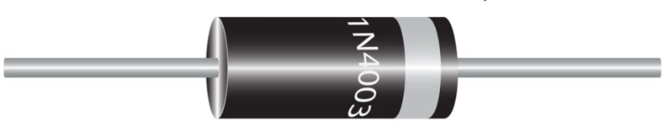

Light Emitting Diode (LED):
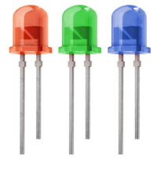
A light-emitting diode (LED) is a semiconductor device that emits light when an electric current flows through it. The longer terminal is Anode and shorter terminal is cathode

Transistor :
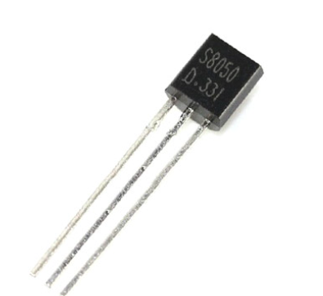
A transistor is a tiny semiconductor device that switches or amplifies electrical signals and power. It serves as a fundamental building block in modern electronics. Bipolar Junction Transistors (BJTs): Controlled by current. They come in two configurations: NPN and PNP.

Breadboard:
A breadboard is a reusable, solderless plastic tool used to build and test temporary electronic circuits by simply pushing wires and components into a grid of holes
Internal Metal Clips: Small metal spring clips sit beneath the holes to grip and connect the pins of electronic parts.
Connected Rows: Sets of five holes in a horizontal row are electrically linked together.
Power Rails: Long vertical strips on the sides (marked with red and blue lines) distribute power across the circuit.
Center Gap: A divide down the middle separates the left and right sides to accommodate integrated circuit chips.
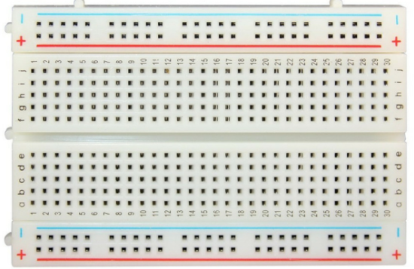

Result: The components were identified and their electrical values were measured successfully.

Precautions:
- Never measure resistance in a powered circuit.
- Observe polarity for diodes, LEDs and electrolytic capacitors.
- Discharge capacitors before measurement.
Viva-Voce Questions
- What is the function of a resistor?
- What does diode-test mode measure?
- Why must resistance not be measured in an energized circuit?
- What is component tolerance?
Experiment 2
Verification of Kirchhoff’s Laws (KVL & KCL)

Aim: To experimentally verify Kirchhoff’s Voltage Law in a series circuit and Kirchhoff’s Current
Law in a parallel circuit.

Digital tools: Tinkercad, DC power supply, resistors, breadboard, digital multimeter,
connecting wires.
Theory:
Kirchhoff Voltage Law (KVL) states that the algebraic sum of voltages around a closed loop is zero. For parallel circuit the voltage gets divided in the different elements.
Kirchhoff Current Law (KCL) states that the algebraic sum of currents at a node is zero; incoming current equals outgoing current. For a series circuit, the same current flows through all elements. In a parallel circuit, branch currents divide according to branch resistance.
Circuit Diagram :
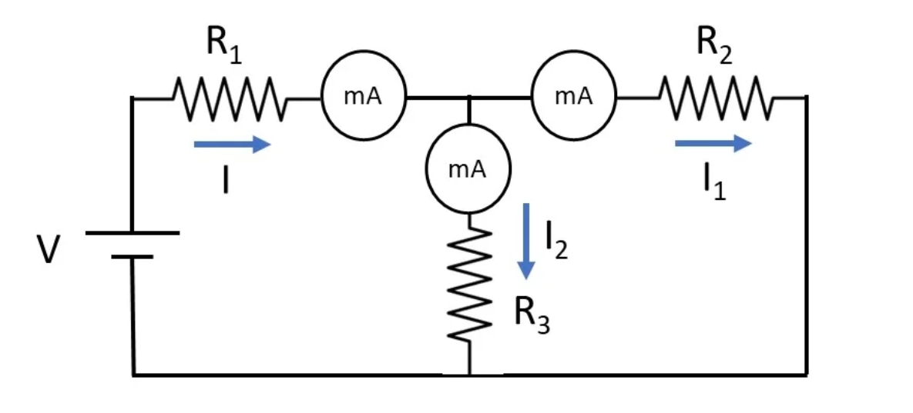

Procedure
1. Make the connection as per the circuit diagram.
2. Set the DC supply to a safe prescribed value.
3. Measure the source voltage and voltage drops across each resistor.
4. Verify that total current is approximately equal to the sum of branch currents.

Observation Table 1: KVL
Sr.No. | Source Voltage | V₁ | V₂ | V₃ | V₁+V₂+V₃ | Difference

Observation Table 2: KCL
Sr.No. | Source Voltage  V_{s} | I₁ | I₂ | Total Current I₀=I₁+I₂ | Difference
Calculations
KVL: V_{s} = V₁ + V2 + V3.
KCL: I₀= I₁ + I₂

Result: KVL and KCL were verified experimentally within practical measurement tolerance.

Viva-Voce Questions
- State and explain KVL.
- State and explain KCL.
- Why is current the same in a series circuit?
- Why does current divide in a parallel circuit?
Experiment 3
- V-I characteristics of P-N Junction Diode

- Zener Diode as Voltage Regulator

Aim: A. To study the V-I characteristics of P-N Junction Diode
B. Study the Zener diode as a diode Voltage-Regulator
.

Simulation Tools and Components: Tinkercad, P-N Junction Diode, Zener diode, resistors, DC
supply, load, breadboard, multimeter, wires.

Theory:
The diode is a device formed from a junction of n-type and p-type semiconductor material. The lead connected to the p-type material is called the anode and the lead connected to the n-type material is the cathode.

Function of a P-N junction Diode in Forward Bias
The positive terminal of battery is connected to the P side(anode) and the negative terminal of battery is connected to the N side(cathode) of a diode.The positive potential applied to the p-type material repels the holes, while the negative potential applied to the n-type material repels the electrons.
With increasing forward-bias voltage, the depletion zone becomes thin enough that the zone's electric field cannot counteract charge carrier motion across the p–n junction, which as a consequence reduces electrical resistance. The electrons that cross the p–n junction into the p-type material (or holes that cross into the n-type material) will diffuse into the nearby neutral region.

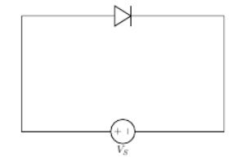

Function of a P-N junction diode in Reverse Bias
The positive terminal of battery is connected to the N side(cathode) and the negative terminal of battery is connected to the P side(anode) of a diode. Therefore, very little current will flow until the diode breaks down.The positive terminal of battery is connected to the N side(cathode) and the negative terminal of battery is connected to the P side(anode) of a diode, the 'holes' in the p-type material are pulled away from the junction, leaving behind charged ions and causing the width of the depletion region to increase.
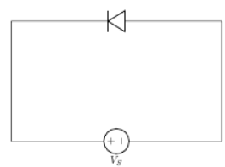
Once the electric field intensity increases beyond a critical level, the p–n junction depletion zone breaks down and current begins to flow, usually by either the Zener or the avalanche breakdown processes. Both of these breakdown processes are non-destructive and are reversible, as long as the amount of current flowing does not reach levels that cause the semiconductor material to overheat and cause thermal damage.
Circuit Diagram:
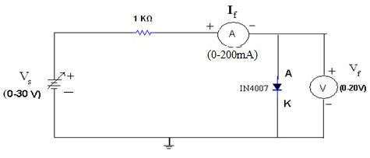
Fig. 1. Forward biased P N junction
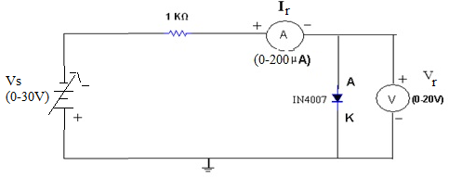
Fig. 2. Reverse biased P N junction
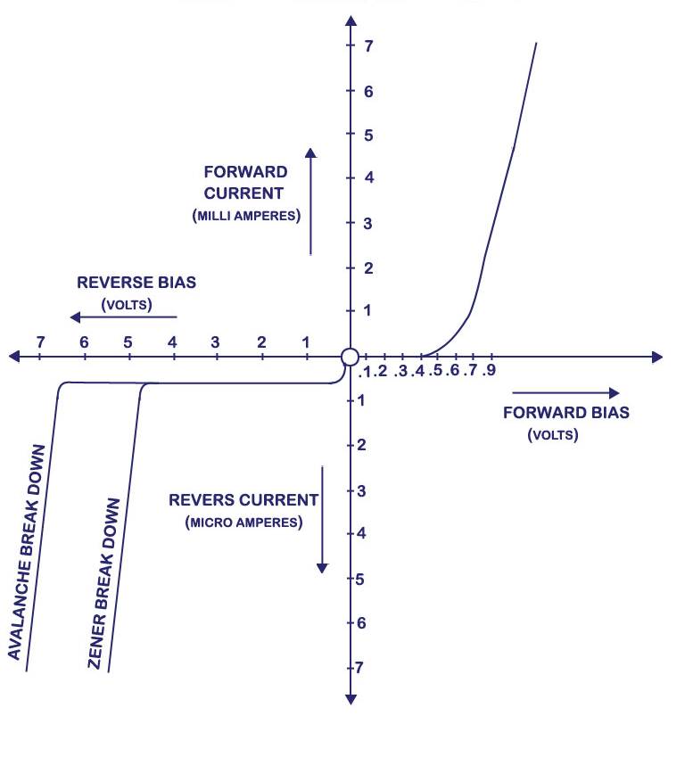
Fig 3. VI Characteristics of Diode
Procedure
- Build the circuit as above on bread board.
- Make the connections and apply the supply voltage.
- Take the voltage and current readings
- Plot the VI characteristics of Diode

Observation Table : Forward Bias
Sr.No. | Forward Voltage(Volt) | Forward Current(mAmp)

Reverse Bias
Sr. No. | Reverse voltage V_{R} (volt) | Reverse Current I_{R} (μA)
B. Study the Zener Diode as a Diode Voltage-Regulator

THEORY:
Special diodes are constructed which can operate at voltage that equal or exceed their breakdown voltage rating. These special diodes are commonly referred to as Zener diode. The overall forward and reverse characteristics of the Zener diode are similar to those of an ordinary junction diode. The primary difference is simple that the Zener diode is specifically designed to operate with a reverse bias voltage that is high enough to Cause the device to breakdown and conduct a high reverse current. Then the reverse current through the diode increases at an extremely rapid rate as the reverse voltage increases beyond the breakdown point.
The V-I curve therefore shows that beyond the breakdown point, a very large change in reverse current is accompanied by only a very small change in reverse voltage. This action occurs because the resistance of the diode drops considerably as its reverse voltage is increased beyond the breakpoint. Once the breakdown point is exceeded the diode is said to be operating in its Zener breakdown region or simply its Zener region.

Circuit Diagram:
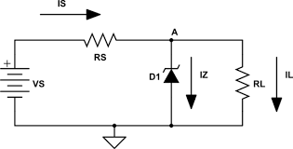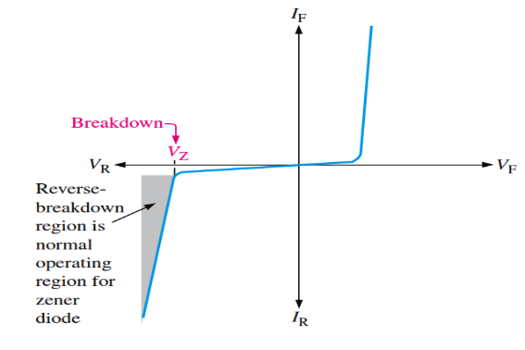
Fig.4. Reverse biased Zener Diode Fig.5 .VI characteristics of Zener diode

Procedure:
- Build the circuit as above on bread board.
- Make the connections and apply the supply voltage.
- Take the voltage and current readings
- Plot the VI characteristics of Zener Diode

Observation Table
Sr.No. | Input Voltage | Output Voltage | Output Current

Result : The Diode V-I characteristics are verified .
Zener-diode as a voltage regulator was observed .

Precautions:
- Use the correct Zener voltage and power rating.
- Always use a current-limiting resistor.
- Do not exceed the maximum current rating.

Viva-Voce Questions
- What is forward bias?
- What is reverse breakdown?
- Why is a resistor used with a Zener diode?
- What is a voltage regulator?
Experiment 4
Study of Half-Wave Rectifier
Aim: To construct a half-wave rectifier, observe input/output waveforms and determine the ripple
factor.

Simulation Tools and Components: Tinkercad, Diode, transformer/low-voltage AC source, load
resistor,breadboard/trainer kit, CRO/DSO, multimeter, wires.

Theory:
The process of converting an alternating current into direct current is known as rectification. The unidirectional conduction property of semiconductor diodes (junction diodes) is used for rectification. Rectifiers are of two types: (a) Half wave rectifier and (b) Full wave rectifier. In a half-wave rectifier circuit during the positive half-cycle of the input, the diode is forward biased and conducts. Current flows through the load and a voltage is developed across it. During the negative half-cycle, it is reverse bias and does not conduct. Therefore, in the negative half cycle of the supply, no current flows in the load resistor as no voltage appears across it. Thus, the dc voltage across the load is sinusoidal for the first half cycle only and a pure a.c. input signal is converted into a unidirectional pulsating output signal.

Circuit Diagram
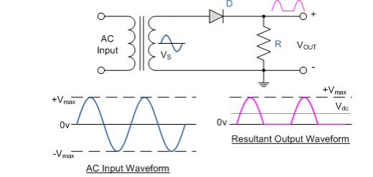
Fig.1. Half-wave rectifier circuit without capacitor filter
Since the diode conducts only in one half-cycle (0-π), it can be verified that the d.c. component in the output is V_{max}/π, where V_{max} is the peak value of the voltage. Thus,
$$Vdc=\frac{Vmax}{π}=0.318 Vmax$$
The current flowing through the resistor is $I_{dc}=V_{dc}/R$ $I_{dc}=V_{dc}/R$ and power consumed by the load, ${P=I}_{dc }^{2}/R$
Ripple factor: As the voltage across the load resistor is only present during the positive half of the cycle, the resultant voltage is "ON" and "OFF" during every cycle resulting in a low average dc value. This variation on the rectified waveform is called "Ripple" and is an undesirable feature. The ripple factor is a measure of purity of the d.c. output of a rectifier and is defined as
$$r=\frac{V_{ac }\left(output\right)}{V_{dc} (output)}=\sqrt{{(V}_{rms}^{2}-V_{dc}^{2 })/V_{dc}^{2} }$$

=$\sqrt{\frac{V_{rms }^{2}}{V_{dc}^{2}}-1 }$ = $\sqrt{\left({0.5}/{0.318 }\right)2- 1}$ =1.21

Rectification Efficiency: Rectification efficiency, η, is a measure of the percentage of total a.c. power input converted to useful d.c. power output.
η = d.c. power delivered to load / a.c. power at input
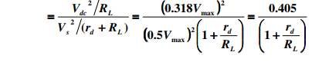
Here r_{d} is the forward resistance of diode. Under the assumption of no diode loss (rd<< the rectification efficiency in case of a half-wave rectifier is approximately 40.5%.
Filters:
The output of a rectifier gives a pulsating d.c. signal because of presence of some a.c. components whose frequency is equal to that of the a.c. supply frequency. Very often when rectifying an alternating voltage we wish to produce a "steady" direct voltage free from any voltage variations or ripple. Filter circuits are used to smoothen the output. Various filter circuits are available such as shunt capacitor, series inductor, choke input LC filter and π-filter etc. Here we will use a simple shunt capacitor filter circuit. Since a capacitor is open to d.c. and offers low impedance path to a.c. current, putting a capacitor across the output will make the d.c. component to pass through the load resulting in small ripple voltage.
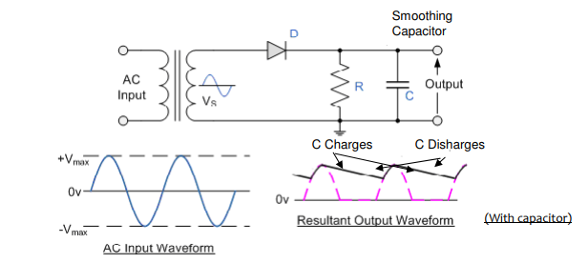
Fig. 2. Half-wave rectifier circuit with capacitor filter
The working of the capacitor can be understood in the following manner. When the rectifier output voltage is increasing, the capacitor charges to the peak voltage Vm. Just past the positive peak the rectifier output voltage tries to fall. As the source voltage decreases below Vm , the capacitor will try to send the current back to diode making it reverse biased. Thus the diode separates/disconnects the source from the load and hence the capacitor will discharge through the load until the source voltage becomes more than the capacitor voltage. The diode again starts conducting and the capacitor is again charged to the peak value Vm and the process continues. Although in the output waveform the discharging of capacitor is shown as a straight line for simplicity, the decay is actually the normal exponential decay of any capacitor discharging through a load resistor. The extent to which the capacitor voltage drops depends on the capacitance and the amount of current drawn by the load; these two factors effectively form the RC time constant for voltage decay. A proper combination of large capacitance and small load resistance can give out a steady output.

Procedure
- Connect the half-wave rectifier circuit as provided in the laboratory diagram.
- Apply the specified low-voltage AC input.
- Observe input and output waveforms on the CRO/DSO.
- Measure DC and AC components as required by the available instrument.
- Calculate ripple factor using the measured values.
- Record observations and compare with the ideal value.
Observation Table
- Code number of diode = ________
- Input Voltage: V_{ac} = _________ V

Half wave rectifier w/o filter
Sr.  No. | Load R_{L} (kΩ) | Output Voltage |  |  | Ripple Factor r | Efficiency (η) (%)
Sr.  No. | Load R_{L} (kΩ) | V_{ac} (Volt) | Vdc (Volt) | V_{max}/ π (Volt) | Ripple Factor r | Efficiency (η) (%)

Half wave rectifier with filter (C = _ μF)
Sl. No | Load  R_{L} (kΩ) | Output Voltage |  | Ripple Factor  r
Sl. No | Load  R_{L} (kΩ) | V_{ac} (Volt) | V_{dc} (Volt) | Ripple Factor  r
1
2
3
(III) Input and output waveforms :( on separate graph sheet)

Calculations:
Ripple factor r = V_{ac}(rms) / V_{dc}. For an ideal half-wave rectifier, r ≈ 1.21.

Result:
The half-wave rectifier waveform was observed and the ripple factor was determined.

Precautions:
- Use only isolated low-voltage AC for student experiments.
- Check diode orientation.
- Do not connect oscilloscope ground clips to unsafe mains points.
Viva-Voce Questions
- What is rectification?
- Why does a half-wave rectifier have high ripple?
- What is ripple factor?
- What is the role of the diode?
Experiment 5
Study of Full-Wave Rectifier (Centre-Tap & Bridge)

Aim: To construct and compare center-tap and bridge full-wave rectifiers with a half-wave rectifier.
Simulation Tools and Components: Tinkercad, Diodes, center-tapped transformer/trainer kit,
four diodes, load resistor, CRO/DSO, multimeter, wires.

Theory:
As you have seen already a half- wave rectifier circuit is unsuitable to applications which need a "steady and smooth" dc supply voltage. One method to improve on this is to use every half-cycle of the input voltage instead of every other half-cycle. The circuit which allows us to do this is called a Full-wave Rectifier Here, unidirectional current flows in the output for both the cycles of input signal and rectifies it. The rectification can be done either by a center tap full wave rectifier (using two diodes) or a full wave bridge rectifier (using four diodes). In this experiment we will study Full wave bridge rectifier.
The Full-wave Bridge Rectifier
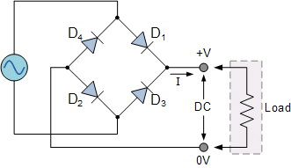
Another type of circuit that produces the same output as a full-wave rectifier is that of the Bridge Rectifier (Fig. 1). This type of single-phase rectifier uses 4 individual rectifying diodes connected in a "bridged" configuration to produce the desired output but does not require a special centre tapped transformer, thereby reducing its size and cost. The single secondary winding is connected to one side of the diode bridge network and the load to the other side as shown in figure. The 4 diodes labeled D1 to D2 are arranged in "series pairs" with only two diodes conducting current during each half cycle. During the positive half cycle of the supply, diodes D1 and D2 conduct in series while diodes D3 and D4 are reverse biased and the current flows through the load as shown above. During the negative half cycle of the supply, diodes D3 and D4 conduct in series, but diodes D1 and D2 switch of as they are now reverse biased. The current flowing through the load is the same direction as before.
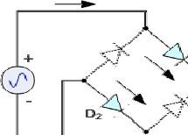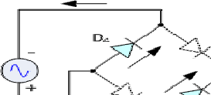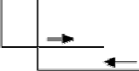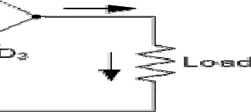
Fig.1. Full-wave rectifier circuit without capacitor filter
As the current flowing through the load is unidirectional, so the voltage developed across the load is also unidirectional during both the half cycles. Thus, the average dc output voltage across the load resistor is double that of a half-wave rectifier circuit, assuming no losses.
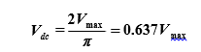
Ripple Factor:
As mentioned in the previous lab the ripple factor is a measure of purity of the d.c. output of a rectifier and is defined as
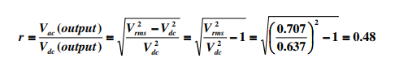
In case of a full-wave rectifier V_{rms} = V_{max}/√2 = 0.707V_{max}. The ripple frequency is now twice the supply frequency (e.g. 100Hz for a 50Hz supply).
Rectification Efficiency:
Rectification efficiency η is given by
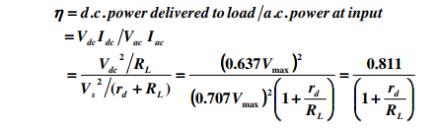
Where r_{d} is the forward resistance of diode. Under the assumption of no diode loss (rd<< the rectification efficiency in case of a full-wave rectifier is approximately 81.1%
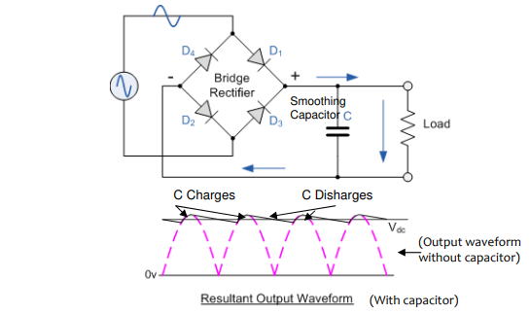
Fig. 2. Full-wave rectifier circuit with capacitor filter
The full-wave rectifier circuit with capacitor filter is shown in Fig. 3. The smoothing capacitor converts the full-wave rippled output of the rectifier into a smooth dc output voltage. The detailed description of its filtering action is already explained in half-wave rectifier handout. Two important parameters to consider when choosing a suitable a capacitor are its working voltage, which must be higher than the no-load output value of the rectifier and its capacitance value, which determines the amount of ripple that will appear superimposed on top of the dc voltage.
Apart from rectification efficiency, the main advantages of a full-wave bridge rectifier is that it has a smaller ac ripple value for a given load and a smaller smoothing capacitor than an equivalent half-wave rectifier. The amount of ripple voltage that is superimposed on top of the dc supply voltage by the diodes can be virtually eliminated by adding other improved filters such as a pi-filter.

Procedure:
- Configure the full-wave rectifier circuit as shown in the circuit diagram. Note down all the values of the components being used.
- Connect the primary side of the transformer to the a.c. Mains and secondary to the input of the circuit.
- Measure the input a.c. voltage (Vac) and current (Iac) and the output a.c. (Vac) and d.c.
(Vdc) voltages using multimeter for at least 3 values of load resistor (Be careful to choose
proper settings of multimeter for ac and dc measurement).
- Feed the input and output to the oscilloscope (we will use oscilloscope here only to trace the
output waveform) and save the data for each measurement. Be careful not to measure the
input and output voltages simultaneously.
- Multiply the Vac at the input by √2 to get the peak value and calculate Vdc Using the formula
- Vdc = 2Vmax/ π. Compare this value with the measured Vdc at the output.
- Calculate the ripple factor and efficiency.
- Connect the capacitor across the output for each load resistor. Measure the output a.c. and
d.c. voltages once again and calculate the ripple factor. Trace the input and output waveforms in oscilloscope and notice the change. (If time permits you could also use different values of capacitors and study the output)

Observation Table:
- Code number of diode = ________
- Input Voltage: Vac = _________ Volt

Table (I):
Full-wave rectifier w/o filter
Sr. No. | Load R_{L} kΩ | Input  Current I_{ac} (mA) | Output Voltage |  |  | Ripple Factor  R | Efficiency η (Vdc2/RL)/VacIac (%)
Sr. No. | Load R_{L} kΩ | Input  Current I_{ac} (mA) | Vac  (Volt) | Vdc  (Volt) | 2V_{max}/ π  (Volt) | Ripple Factor  R | Efficiency η (Vdc2/RL)/VacIac (%)

Table (II):
Full-wave rectifier with filter (C =__________ μF)
Sr. No. | Load  R_{L} (kΩ) | Output Voltage |  | Ripple Factor  r
Sr. No. | Load  R_{L} (kΩ) | V_{ac} (Volt) | V_{dc} (Volt) | Ripple Factor  r

Draw:
Waveforms without Filter:

Waveforms with Filter:

Result:
Centre-tap and bridge full-wave rectification were studied and compared with half-wave rectification.
Precautions:
- Check all diode polarities.
- Use low-voltage isolated sources.
- Avoid shorting transformer terminals.
Viva-Voce Questions
- Why is full-wave rectification better than half-wave?
- How many diodes are used in a bridge?
- What is the main advantage of a bridge rectifier?
- Why is a center-tapped transformer required in the center-tap circuit?
- Draw the waveform of HWR and FWR on graph paper.
- Compare HWR, FWR and bridge rectifier.

